**Software paper for submission to the Journal of Open Research Software**

To complete this template, please replace the blue text with your own. The paper has three main sections: (1) Overview; (2) Availability; (3) Reuse potential.

Please submit the completed paper to: editor.jors@ubiquitypress.com

**(1) Overview**

Title

WPTherml: A Python Package for the design of materials for harnessing heat.

Paper Authors

1. James F. Varner

2. Noor Eldabagh

3. Derek Volta

4. Reem Eldabagh

5. Jonathan J. Foley IV (corresponding author)

Paper Author Roles and Affiliations

1. Software development, planning, and testing, co-wrote the manuscript and documentation. Department of Chemistry, William Paterson University, 300 Pompton Road, Wayne, NJ 07470

2. Software development and testing. Department of Chemistry, William Paterson University, 300 Pompton Road, Wayne, NJ 07470

3. Software development and testing. Department of Chemistry, William Paterson University, 300 Pompton Road, Wayne, NJ 07470

4. Software development and testing. Department of Chemistry, William Paterson University, 300 Pompton Road, Wayne, NJ 07470

5. Project conception, software development, planning, and testing, co-wrote the manuscript and documentation. Department of Chemistry, William Paterson University, 300 Pompton Road, Wayne, NJ 07470

Abstract

A short (ca. 100 word) summary of the software being described: what problem the software addresses, how it was implemented and architected, where it is stored, and its reuse potential.

WPTherml is a Python package for the design of materials with tailored optical and thermal properties for the vast number of energy applications where control of absorption and emission of radiation, or conversion of heat to radiation or vice versa, is paramount. The optical properties are treated within classical electrodynamics via the Transfer Matrix Method which rigorously solve Maxwell's equations for layered isotropic media. A flexible multilayer class connects rigorous electrodynamics properties to figures of merit for a variety of thermal applications, and facilitates extensions to other applications for greater reuse potential. WPTherml can be accessed at https://github.com/FoleyLab/wptherml.

Keywords

keyword 1; keyword 2; *etc.*

Keywords should make it easy to identify who and what the software will be useful for.

Nanophotonics, Solar Thermophotovoltaics, Passive Cooling, Radiative Cooling, Computational Electrodynamics, Concentrated Solar, Transfer Matrix Method

Introduction

An overview of the software, how it was produced, and the research for which it has been used, including references to relevant research articles. A short comparison with software which implements similar functionality should be included in this section.

In 2017 over sixty five percent of energy produced was not useable and released as waste heat (Graphic & citation); consequently, there are a large number of opportunities to develop technologies which can mitigate waste heat associated with energy production, or which can be used to convert or reclaim waste heat for useful purposes. Materials with tailored optical and thermal emission properties are centrally important for many of these envisioned technologies, which include solar thermophotovoltaicsradiative ,incandescent lights that minimize IR radiation, among others. WPTherml (**W**illiam **P**aterson University's tool for **Th**ermal **E**nergy and **R**adiation management with **M**ulti **L**ayer nanostructures), is a computational engine for materials which can be leveraged for these and other technologies where the control of optical and/or thermal radiation properties are paramount. Specifically, WPTherml can be utilized to simulate and design multilayer planar nanostructures made from isotropic media. WPTherml computes spectral properties and and images for the design of multi-layer nano-structures. These structures could have applications in STPV, TPV, cooling power, and highly efficient light bulbs. Management of photonic thermal energies as an energy source may have many beneficial impacts, in multiple markets including clean energy, military use and the consumer market. Concentrated solar power as an STPV application that has benefits for all of the listed markets. Using Wptherml a multilayer nano-structure can be designed to produce a light spectrum that closely matches that of the response function of a PV cell to have maximum energy conversion. The response function of a PV cell is unique to the crystalline structure of the PV cell and the band gap energy of the crystal. If the thermal emission can be tailored into the proper range of wavelengths, then the energy conversion will have high efficiency.

*Response function pictures*

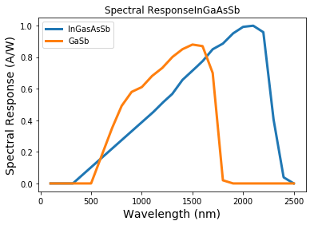

Figure 1 Response funtions of InGaAsSb and GasSb PV cells. An emitter that emit photons at wave lengths under the two curves will be absorbed. Photons at the wavelength of the local maxima will be fully absorbed. Photons below or above the maximum absorbance will not have all of its energy absorbed

The core of WPtherml is the transfer matrix method (TMM) (eq1). TMM is built up from a sequence of matrices, matrix P (eq2), matrix D (eq3) and the Inverse of matrix D.The sequence is multiplied for n layers of material where air is a semi-infinite layer. The P matrix considers the thickness of each layer. The D matrix considers Snell’s law and how the angle of the light vector changes when changing layers. The D matrix is also specific to the polarization of the light traversing the surface, “s” or “p”. The resulting matrix “M” is then used to find the emissivity by multiplying the magnitudes of transmission and reflection by their complex conjugate the real values for transmission and reflection are calculated. The magnitude of reflectance is calculated by dividing M2,1 by M1,1 from the transfer matrix method. The magnitude of transmission is calculated by dividing one by M1,1 from the transfer matrix method. Kirchhoff’s law is then used to calculate emissivity which is equivalent to emissivity (rousac and rousac). The emissivity is finally multiplied by the black body spectrum at the specific temperature of the structure to determine the thermal emission of a multi-layered nano structure. The thermal emission spectrum can be compared to ideal functions to determine the usefulness of a structure.

$$\left(\begin{matrix}M_{1,1} & M_{1,2} \\ M_{2,1} & M_{2,2}\end{matrix}\right)=D_{1}^{-1} \left(\prod_{l=2}^{L-1}{D_{l} P_{l} D_{l}^{-1}}\right)D_{L}$$

$$r=\frac{M_{2,1}}{M_{1,1}} t=\frac{1}{M_{1,1}}$$

$$a=ϵ=1-R-T$$

Figure 2 TMM definition and eqations to calculate reflectance, transmittance and absorbance.

STPV is an under researched forward moving clean energy source that could allow for cheap and efficient energy harnessing. The idea behind this type of energy conversion is to create a new light source that better fits a PV cell’s response function.(nature fan) By using properly angled mirrors the sun light can be concentrated onto a black absorber, a good absorber being Tungsten. The concentrated sun light also heats the black absorber that then conducts heat to a multi-layer emitter structure. Applications of this software for STPV include making calculations for the light vector in a Bragg reflector. A Bragg reflector is a periodically repeating structure consisting of *N* layers and *nN* refractive indices. The alternating layers have different refractive indices one with a high reflective index and the other with a low refractive index. Bragg reflectors exhibit unique thermal optical properties. Due to the periodicity of a Bragg reflector the structure exhibits a resonance reflection similar to X-ray diffraction in crystal lattices (Pochi Yeh 129). The electromagnetic waves traverse a Bragg reflector from the surface to the terminal interface. By adding layers under an optically thick piece of tungsten spectral conversion efficiency and power emitted increases as layers increase. (either poochi yeh or nano optics book).

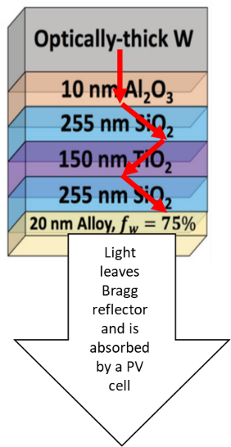 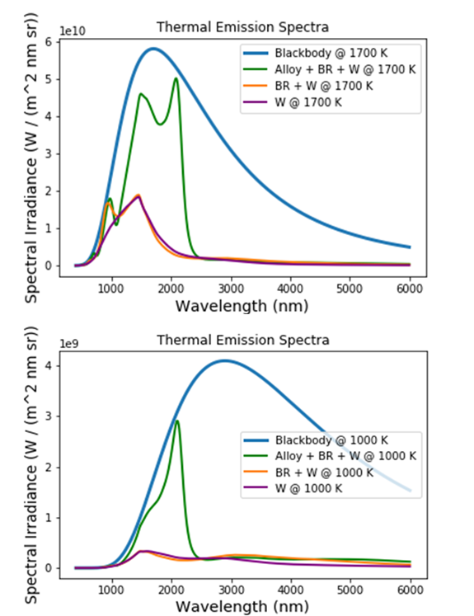

Incandescent light bulbs have efficiencies approaching that of LED when designed to minimize waste radiation. A light bulb filament can be designed to fit closer to the gaussian function of optical response, similar to the STPV application where light source is designed to provide energy to a PV cell. There are many approaches to this involving multi layers or photonic crystals. The thermal emission spectra of tungsten emits in the IR which is not seen by the human eye. The goal of controlling the thermal emission in this case would be to minimize IR radiation from the light source such that the encasing design should have minimal IR radiation to prevent from escaping the bulb. Additionally if the emitter emits in the optical detection spectrum it would provide the best quality light. Incandescent Light bulbs reach temperatures of 2400 K???? Which limits the list of useable metals as many metals oxidize at high temperatures. A very promising filament is graphene, due to its electrical conductivity. Unfortunately, graphene readily oxidizes at high temperatures. Graphene oxidizes at xxxx K and there for cannot be used as a filament. When graphene is coated with hexagonal boron nitride the boron nitride rings prevent oxidation of the metal. It is possible to determine optical properties of structures containing this coating to determine if non-oxide metals will make a viable incandescent filament. (Graphene hot-electron light bulb: Incandescence from hBN-encapsulated graphene in air).

Radiative cooling uses highly reflective materials that emits in wave lengths the atmosphere is transparent to. This is used to cool the surface of the reflector pushing heat from the surface to space. This technology can cool buildings and reduce or even eliminate the use of air conditioners saving money and requiring less energy to cool off buildings. This technology could be used for anything that needs to be cooled outside. One use maybe cars. Drivers will save money on gas and produce less carbon emissions. Shanhui Fans group designed a multi-layer nano-structure that had a temperature 5 C less than the ambient air temperature. This has shown that the optical the thermal properties can be used to cool surfaces and buildings by reflecting and thermally emitting into the atmosphere.

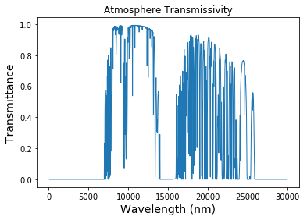

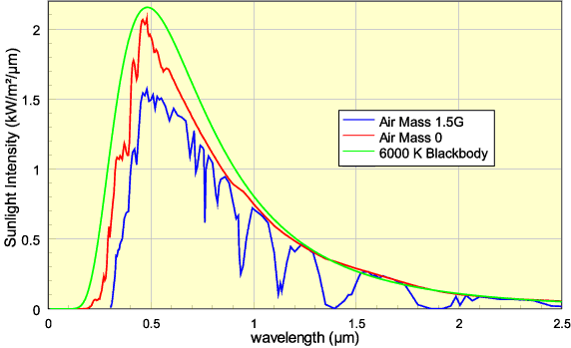

Figure 3This is an internet image that needs to be reproduced

**Implementation and architecture**

How the software was implemented, with details of the architecture where relevant. Use of relevant diagrams is appropriate. Please also describe any variants and associated implementation differences.

WPTherml is written is written in pure Python 3 with minimal dependencies including numpy, scipy, and matplotlib. The major parts of WPTherml include the multilayer class, the function libraries (tmm, numlib, stpvlib, coolinglib, colorlib, and lightlib), and the data library (datalib). The function libraries contain the functions that perform calculations to extract spectral information and figures of merit for the various applications supported by WPTherml as follows:

* tmm uses transfer matrix method to compute various optical properties
* numlib provides a simple function for numerical quadrature
* stpvlib uses optical properties and thermal emission to compute figures of merit relevant to solar thermophotovoltaic applications
* coolinglib uses optical properties and thermal emission to compute figures of merit relevant to radiative cooling
* colorlib uses optical properties and thermal emission to render color of structures
* lightlib uses optical properties and thermal emission to compute figures of merit relevant for incandescent light sources.

The data library datalib provides data to support various calculations, including

* Refractive index as a function of wavelength for an extensive number of common materials, required for computing optical properties
* Spectral Response functions for several common photovoltaic materials, required for computing STPV and standard PV efficiencies
* AM1.5 spectral data required for various solar calculations
* Atmospheric transmission spectrum required for radiative cooling applications
* Spectral response functions for the human eye, required for rendering color of structures and for computing the luminous efficiency of incandescent lightsources

The multilayer class groups and arranges how the calculations occur in an object oriented method. The class structure interacts with the libraries to use functions from the libraries. The benefit of the class structure are the organization and easy to access a group of functions for a specific application.

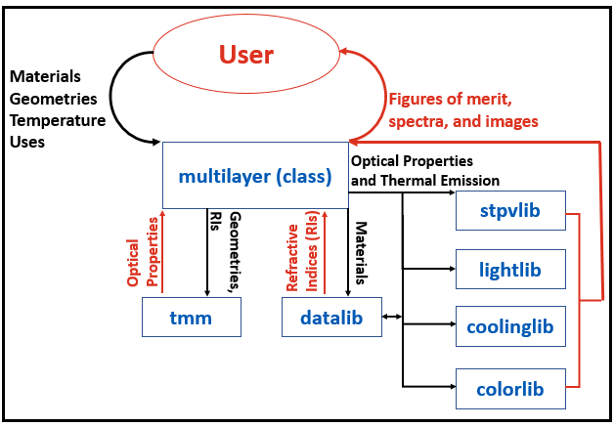

**Quality control**

Detail the level of testing that has been carried out on the code (e.g. unit, functional, load etc.), and in which environments. If not already included in the software documentation, provide details of how a user could quickly understand if the software is working (e.g. providing examples of running the software with sample input and output data).

**(2) Availability**

***Operating system***

WPTherml has been tested on MacOS Sierra, Windows 10, and Fedora 22. Since WPTherml is written in Python, it should run on any system on which Python and the WPTherml dependencies run.

***Programming language***

WPTherml is written in Python 3 and has been tested with Anaconda Python (3.6 and 3.7).

***Additional system requirements***

E.g. memory, disk space, processor, input devices, output devices.

***Dependencies***

WPTherml depends on numpy, scipy, and matplotlib.

The code was tested with

* numpy version 1.14.3
* scipy version 1.1.0
* matplotlib version 2.2.2

***List of contributors***

Please list anyone who helped to create the software (who may also not be an author of this paper), including their roles and affiliations.

***Software location:***

***Archive*** (e.g. institutional repository, general repository) (required – please see instructions on journal website for depositing archive copy of software in a suitable repository)

***Name:*** The name of the archive

***Persistent identifier:*** e.g. DOI, handle, PURL, etc.

***Licence:*** Open license under which the software is licensed

***Publisher:*** Name of the person who deposited the software

***Version published:***The version number of the software archived

***Date published:*** dd/mm/yy

**Code repository**

***Name:*** GitHub

***Identifier:*** https://github.com/FoleyLab/wptherml

***Licence:*** GPL 3.0

***Date published:*** dd/mm/yy

**Emulation environment** (if appropriate)

***Name:*** The name of the emulation environment

***Identifier:*** The identifier (or URI) used by the emulator

***Licence:*** Open license under which the software is licensed here

***Date published:*** dd/mm/yy

***Language***

Language of repository, software and supporting files

Python 3

**(3) Reuse potential**

Please describe in as much detail as possible the ways in which the software could be reused by other researchers both within and outside of your field. This should include the use cases for the software, and also details of how the software might be modified or extended (including how contributors should contact you) if appropriate. Also you must include details of what support mechanisms are in place for this software (even if there is no support).

Wptherml was written with multiple applications that allow endless possible structures to design. The library functions available include a large array of potential research projects. Including energy production cooling and green light bulbs.

**Acknowledgements**

Please add any relevant acknowledgements to anyone else who supported the project in which the software was created, but did not work directly on the software itself.

**Funding statement**

If the software resulted from funded research please give the funder and grant number.

**Competing interests**

If any of the authors have any competing interests then these must be declared. The authors’ initials should be used to denote differing competing interests. For example: “BH has minority shares in [company name], which part funded the research grant for this project. All other authors have no competing interests."

If there are no competing interests, please add the statement:

“The authors declare that they have no competing interests.”

**References**

Please enter references in the Harvard style and include a DOI where available, citing them in the text with a number in square brackets, e.g.

[1] Piwowar, H A 2011 Who Shares? Who Doesn't? Factors Associated with Openly Archiving Raw Research Data. *PLoS ONE* 6(7): e18657. DOI: <http://dx.doi.org/10.1371/journal.pone.0018657>.

# References

1. **Yeh, Pochi.** *Optical Waves in Layered Media.* New York : Wiley, 1988.

2. **Ilic, Ognjen, et al.** Tailoring High Temprature Radiation and the Ressurection of the Incandescent Source. *Nature Nanotechnology.* 2016.

3. **Jean, Nari, et al.** Pareto Optimal Spectrally Selective Emitters for Thermophotovoltaics via Weak Absorber Coupling. *Advanced Energy Materials.* 2018.

4. **Raman, Aaswath, et al.** Passive Radiative cooling below ambient air temprature under direct sunlight. *Nature .*

**Copyright Notice**

Authors who publish with this journal agree to the following terms:

Authors retain copyright and grant the journal right of first publication with the work simultaneously licensed under a [Creative Commons Attribution License](http://creativecommons.org/licenses/by/3.0/) that allows others to share the work with an acknowledgement of the work's authorship and initial publication in this journal.

Authors are able to enter into separate, additional contractual arrangements for the non-exclusive distribution of the journal's published version of the work (e.g., post it to an institutional repository or publish it in a book), with an acknowledgement of its initial publication in this journal.

By submitting this paper you agree to the terms of this Copyright Notice, which will apply to this submission if and when it is published by this journal.